**Brooklyn torah gazette**

**For parshas pinchas 5782**

Volume 6, Issue 43 (Whole Number 298) 24 Tammuz 5782/ July 23, 2022

**The Legendary Righteous Sulika of Tangiers, Morocco**

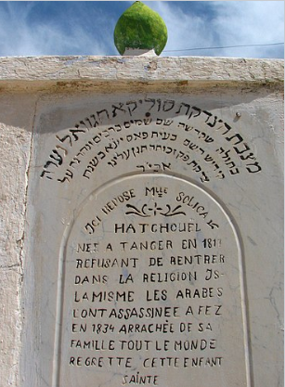

**The tombstone of Sulika Hatzadeket**

Beside the graves of all the righteous rabbis buried in Fez, Morocco, is the grave of Sulika Hatzadeket Righteous Sulika,”, a young woman who was killed by the Muslim authorities.

Who is Sulika, and why did she earn an eternal resting place among the Hachamim? Around the year 1830, a Jewish family by the name Hachuel lived in the Moroccan town of Tangiers. Sulika, the daughter of Chaim and Simcha, was very beautiful and remarkably modest.

She became well known among the Jews of Tangiers for her chesed, kind heart and goodwill. Chaim was a merchant by trade but was also very knowledgeable in Torah, even conducting Talmudic study groups in his home.

**A Boy from One of the Wealthiest**

**Neighboring Muslim Families**

One day, a boy from one of the wealthiest neighboring Muslim families saw Sulika and desired to marry her. The young man’s father threatened Sulika’s family that if they would not allow Sulika to convert to Islam and marry his son, they would suffer bitterly.

Overcome with fear, the family instructed Sulika to hide in the home of a close friend. A short while later, soldiers came to the Hachuel home to arrest Sulika. When they did not find the girl there, they arrested the mother, instead, and kept her in confinement until Sulika would be found.

Upon hearing what happened to her mother, Sulika immediately surrendered to the authorities, who brought her before a Muslim judge. The rich neighbor accused her of having converted to Islam and wanting to return to Judaism, a crime punishable by death under Islamic law.

The court ordered Sulika to return to Islam or face execution. But Sulika remained defiant, “A Jewess I was born and a Jewess I wish to die,” she proudly proclaimed, prepared to die Al Kiddush Hashem.

**Refuses to be Intimidated by the Islamic Judge**

The judge was furious and threatened Sulika with torture. Sulika replied, “I will patiently bear the weight of your chains, I will give my limbs to be torn piece-meal by wild beasts . . . but I will smile at your indignation and the anger of your prophet. Since neither he nor you have been able to overcome a weak female!”

They placed Sulika in a lightless dungeon with an iron collar around her neck and chains on both her hands and feet. They then decided to send her to the Sultan to decide her fate.

The Chachamim of Fez were inspired by Sulika’s dedication. But they were ordered by the Sultan’s judge to extract a confession from the girl that she had previously converted to Islam. The Chachamim went to Sulika and explained that the Jews of Morocco could be endangered if the authorities didn’t get what they want.

Sulika responded with firm resolve that she would maintain her untainted commitment to Judaism until the very end, and the hachamim rejoiced in their hearts.

At the final stages of the trial, one of the sons of the Sultan saw Sulika and, similarly taken by her beauty, made her a lavish offer. If she agreed to convert to Islam and marry him, the prince promised, her life would not only be saved, but she would live in wealth and honor.

Without hesitation, Sulika rebuffed the offer and announced that she could not betray G-d. In spite of his embarrassment by her initial rejection, the prince tried to convince her once more, but Sulika stood firm in her decision. Her tragic fate was sealed, and the prince ordered her immediate execution.

Just before she was killed, the executioner offered her one last chance to convert. Sulika remained firm: “Do not make me linger—behead me at once—for dying as I do, innocent of any crime, the G-d of Abraham will avenge my death!”

(Eugenio Maria Romero. El martirio de joven Hachuel o la heroina Hebrea, Gibraltar, Imprinta Militar, 1837, published as an anonymous English translation, Jewish Heroine of the Nineteenth Century: A Tale Founded on Fact, London, 1839; Malche Rabanan by Rabbi Yosef Benaim; Netivot Hamarav by Rabbi Daniel Abitol)

Reprinted from the Parshat Pinchas 5782 email of R’ Yedidye Hirtenfeld’s whY I Matter parsha sheet for the Young Israel of Midwood in Brooklyn, NY.

**Rav Avigdor Miller on**

**Why Hashem Hides**



**QUESTION: Why is Hashem in hiding?**

**ANSWER:** Why is Hashem hiding from us?

The answer is that otherwise it wouldn’t pay to live.  If Hakodosh Boruch Hu would come out in the open and show His presence, then all the Italians would become loyal servants of Hashem. And all the Puerto Ricans too.  Everybody would become good and frum because if you can see Hashem, who is going to be such a lunatic and disobey?!

Suppose you have a policeman pointing a gun at you and the policeman says, “Hands up or I’ll shoot.”  Where would your hands be?  In your pocket?

And therefore if Hakodosh Boruch Hu would show Himself, will you deserve any credit? And it wouldn’t pay in this world; if you won’t earn anything with your bechirah, with your free will, what’s the use of living?

In the next world when it’s all over and there’s no more free will, then Hakodosh Boruch Hu shows Himself in all His glory and צדיקים יושבים ועטרותיהם בראשיהם ונהנין מזיו השכינה.  The tzaddikim gaze at the splendor of the Shechina and that’s their happiness.

But in this world, it would be the worst thing for us if Hakodosh Boruch Hu was seen openly.  Our job is to discover Him from the places where He’s hiding.

TAPE # 417

*Reprinted from July 7, 2022 email of Toras Avigdor. Adapted from Tape #417 (January 1993)*

**Recognizing the Significance and Relevancy of Performing a Difficult Mitzvah with Many Obstacles**

**From the Talks of the Lubavitcher Rebbe**

**Rabbi Menachem Mendel Schneerson, Zt”l**

This week's Torah portion, Pinchas, details the manner in which the land of Israel was to be apportioned between the Twelve Tribes. The Torah states: "According to the mouth of the lot shall the inheritance of each be divided."

The lot determined which section of the Land of Israel each tribe would inhabit. It was not a rational process, but a method of dividing the land in which no logical reasoning was apparent.

According to Chasidic philosophy, the physical plane of existence is a reflection of its higher spiritual source. It follows, therefore, that just as the division of the Land of Israel was accomplished by means of a lot, so too are certain aspects of a Jew's spiritual service determined in a super-rational manner.

To explain: Every Jew is obligated to keep all of the Torah's mitzvot. However, certain commandments are more pertinent to some individuals than to others.

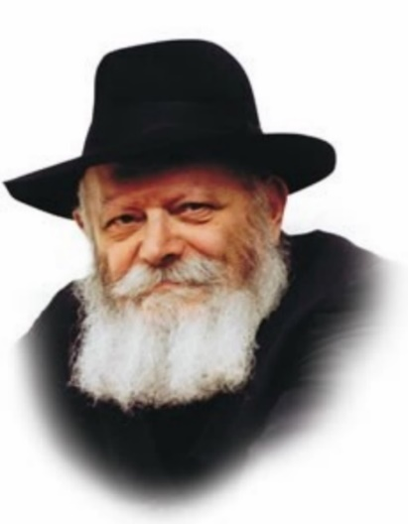

We are told of various Sages of long ago who were especially scrupulous in their performance of one mitzva. Of course, being Tzadikim, they observed all the Torah's commandments. But one mitzva was more personally relevant than all the rest. How do we explain this?

That a particular mitzva has special significance for a given individual is not something that can be explained rationally; the person himself doesn't necessarily perceive that this is so, either. In truth, it is a matter that transcends intellectual understanding, just like the process of choosing by lot. Indeed, the particular mitzva that is most relevant to each of us is determined from Above.

**Being Especially Carefl in One**

**Particular Area of Spirituality**

The Jew's function in life is to be especially careful in that one area, and to observe that mitzva to the best of his ability.

The simplest way to determine which mitzva is the most vital to us personally is by examining the relative ease or difficulty we encounter in observing it. As a general rule, the mitzva we find the most difficult to fulfill is the one that is most imperative on a personal level. In fact, the hardship we experience is proof of this, as the evil inclination, recognizing the mitzva's special significance, will spare no effort in trying to deter us. The machinations of the evil inclination increase in direct proportion to the mitzva's importance.

The lesson to be learned is tremendous. Whenever we find it exceptionally difficult to do a certain mitzva, or it seems that the effort required of us is greater than that required of other people, it is forbidden to throw up our hands in defeat. On the contrary, we must try even harder in that one area, as it is most relevant to us personally. Indeed, the mitzva for which we must overcome the greatest number of obstacles is the one which can be said to have fallen to our lot.

*Reprinted from the Parshat Balak 1997/5757 (Issue #478) edition of L’Chaim Weekly, a publication of the Lubavitch Youth Organization in Brooklyn, NY. Adapted from Likutei Sichot, Volume 2.*

**Rabbi Berel Wein on**

**Parshat Pinchas 5782**

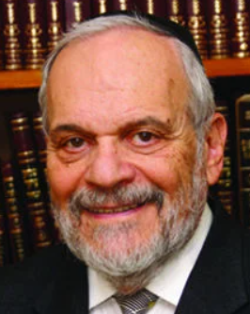

This week's Torah portion warns us not to be swept away by current culture, media, and societal popularity, and by those who are quick to condemn others for their thoughts and actions.

When Pinchas killed Zimri and his consort, he was roundly criticized and threatened by the those in Jewish society because of this act of zealotry. When this act occurred, society considered it to be wrong, harmful, and worthy of criticism. Later, in the full light and perspective of the time, this act was not only acceptable, but the obvious path necessary, and, in fact, heroic.

Pinchas’ critics mentioned the fact that his own pedigree was uncertain, since, although he was the grandson of Aaron, he was also a product of a woman who was of Midianite origin. Moshe himself was married to a daughter of Yitro the high priest of Midian and did nothing. By what right, then, did Pinchas take it upon himself to commit this double killing?

Implicit in this is the accusation as to who made him the zealot, the enforcer, so to speak, of G-d's will. This was a usurpation of power and status that he arrogated to himself. In short, Pinchas was not to be seen as a hero or as a holy person. But, rather, he was considered the impetuous upstart that committed a double killing without proper sanction or legality. The Torah records that heaven itself intervened to set the record straight, and to clearly support and justify the behavior and actions of Pinchas.

There are so many times in history that this story has repeated itself, albeit always under different circumstances. History turns temporary heroes, beloved in their time, into eternal villains when judged by later historical facts and occurrences. History can also rehabilitate people and ideas that were once scorned, held up to ridicule and contempt, and show how the original judgment, event or person was faulty.

There have been many movements and personalities in the history of the Jewish people who achieved temporary fame and popularity, but who are completely forgotten in the long view that history grants us. And many who were criticized, called obstructionists and out of touch with society, have proven to be prescient and heroic in retrospect.

We are always quick to judge, especially when we have our own preconceived ideas as to what is or what should be. We can look back and see the mistakes of previous generations, of physical and spiritual tragedy within the Jewish world. Yet, somehow, we also continue today to allow our own personal biases to affect our judgment of events, leaders, and ideas. This is one of the most fundamental ideas that we can learn from the reading of this week. It is especially relevant to our current society and its challenges.

Shabbat shalom

*Reprinted from the current website of rabbiwein.com*

**15 Facts You Should Know About Elijah**

**By**[**Menachem Posner**](https://www.chabad.org/search/keyword_cdo/kid/12145/jewish/Posner-Menachem.htm)

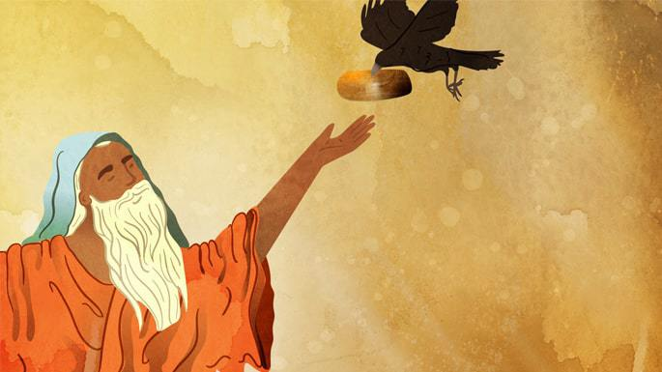

**1. His Story Is Told in Kings and Chronicles**

Perhaps the most famous of the Jewish prophets (after Moses, of course), Elijah’s activities are told in the Book of Kings—starting in I Kings 17 and ending in II Kings 2. In II Chronicles 21, there is also record of a scathing letter he sent to King Jehoram, who did not lead righteously. Elijah did not, however, leave us with a book of his prophecies, so there is no volume of the Bible that bears his name.

**2. He Chastised an Evil King and Was Fed by Ravens**

Elijah first appears in I Kings 17, where is identified as a resident of Toshav (he was hence known as a “Tishbi”) from the region of Gilead. After he told the evil King Ahab that there would be no dew or rain, G‑d told him to hide in a valley, where he was sustained by ravens who brought him meat and bread twice a day.[1](javascript:doFootnote('1a5577280');)

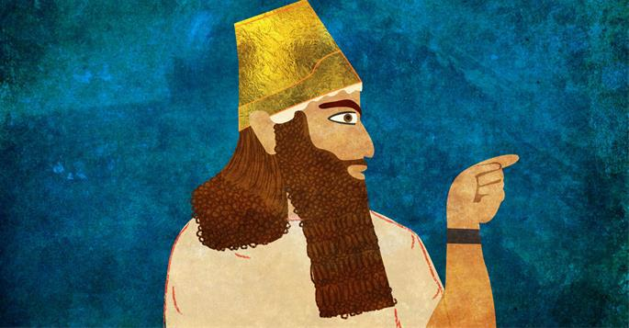

**3. He Revived a “Dead” Boy**

Elijah eventually left his hideout because there was no water to drink, and [G‑d](https://www.chabad.org/library/article_cdo/aid/433240/jewish/God.htm) directed him to a certain widow who would care for him. The woman was poor and did not even have enough for herself and her son, but she gave what she had to Elijah. In return, Elijah promised her that her small jar of flour and flask of oil would never run out from that time on.

The woman’s son eventually took ill and “no soul was left within him.” Elijah took the boy to his attic room, where he called out to G‑d. G‑d listened to Elijah and the boy came back to life.[2](javascript:doFootnote('2a5577280');)

**4. He Defended G‑d at Mt. Carmel**

During Elijah’s time, prophets of G‑d were persecuted and often killed, and the people adopted the idolatrous cult of Baal. To demonstrate the fallacy of idol worship, he invited 450 priests of Baal to a contest on Mount Carmel.

First he invited them to set up an altar and sacrifice to their god, using whatever rituals they wished to invite down a fire from heaven, but none came. Then, he set up a waterlogged sheep on a wet altar, and prayed to G‑d that fire would come. When the fire came d

**5. He Met G‑d at Mount Sinai**



Queen Jezebel, who was even nastier than her husband Ahab, was none too pleased to learn that Elijah had trounced the priests of Baal, and he was forced to flee. After 40 days of walking (fueled by a miraculous meal supplied by an angel), he came to “the mountain of G‑d, Horeb,” which is identified as Mount Sinai. A great wind swept through, followed by an earthquake, and a fire. But G‑d was in none of them—instead appearing in a still, small sound. G‑d then commanded him to leave the Holy Mountain and return to the people.[4](javascript:doFootnote('4a5577280');)

This is the only recorded incident of anyone in the Bible ever returning to Mount Sinai after the revelation that took place shortly after the Exodus.

**6. He Was Hairy**

The Bible rarely gives us much detail about how people looked, but one interesting fact we know about Elijah is that he was blessed with much hair and that he wore a leather belt. After King Ahaz fell through his bed, he sent messengers to idolatrous temples to inquire whether he would survive his injuries. An angel told Elijah to send the message that he would die. After the messengers told the king that the man who spoke to them was hairy and had a leather sash, he correctly identified him as Elijah.[5](javascript:doFootnote('5a5577280');)

**Fun fact:** This is in direct contrast to his prime student, Elisha, who was mocked for being bald. [6](javascript:doFootnote('6a5577280');)

**7. He Ascended to Heaven Alive**



Elijah’s life on earth ended in a most dramatic fashion. Together with his student and successor Elisha, Elijah crossed the Jordan River, which he split by striking it with his cloak.

As the two walked and talked, a fiery chariot drawn by fiery horses pulled up between them, and Elijah was whisked up to heaven.[7](javascript:doFootnote('7a5577280');)

**8. He Frequently Returns to Earth**

Jewish literature has many references to people who interacted with Elijah hundreds and thousands of years after he ascended to heaven. At times, he appears to Torah scholars at night and teaches them the secrets of [Torah](https://www.chabad.org/library/article_cdo/aid/1426382/jewish/Torah.htm) (this is known as *giluy Eliyahu*), and at times he shows up at just the right moment to assist people in distress.

**Fun fact:** He flies to perform his missions in four hops.[8](javascript:doFootnote('8a5577280');)

**9. Dogs Sense His Presence**

The Talmud tells us that when dogs cry we can know that the “Angel of Death” has come to town, and when they laugh we know that Elijah has come.[9](javascript:doFootnote('9a5577280');)

**10. A Midrash Bears His Name**

A classic Midrashic work, *Tana D’bay Eliyahu (“It Was Taught in [the Academy] of Elijah),* contains many of the teachings Elijah the Prophet transmitted to sages of later generations, most notably through Rav Anan. The work is divided into two sections, *Seder Eliyahu Rabbah (“The Great Order of Elijah”)* and [*Seder*](https://www.chabad.org/holidays/passover/pesach_cdo/aid/1980/jewish/Passover-Seder.htm)*Eliyahu Zuta (“The Minor Order of Elijah”).*

**11. He Attends Circumcisions**



At every circumcision, it is traditional to designate a chair for Elijah the Prophet, the “Angel of the Covenant.” Why? When Elijah was at Mount Sinai, he complained to G‑d that the people had stopped circumcising their sons.[10](javascript:doFootnote('10a5577280');)

“I vow,” replied G‑d, “that whenever My children make this sign in their flesh [i.e., whenever there is a circumcision], you will be present, and the mouth which testified that the Jewish people have abandoned My covenant will testify that they are keeping it.”[11](javascript:doFootnote('11a5577280');)

**12. He Also Swoops Into Seders All Over the World**

For the first thousand-plus years of our nation’s history, the Passover Seder centered around sacrificing and eating the [Passover](https://www.chabad.org/holidays/passover/default_cdo/jewish/Passover.htm) Lamb. While all Jewish females were welcome to partake, males could only do so if they were circumcised.[12](javascript:doFootnote('12a5577280');) Thus, there is a time-hallowed custom to open the door and invite in Elijah, who can “testify” that all present are indeed circumcised.

**13. He Is Identified as Pinchas**

Elijah describes himself as a zealot for G‑d,[13](javascript:doFootnote('13a5577280');) mirroring terminology used to describe Pinchas,[14](javascript:doFootnote('14a5577280');) Aaron’s grandson, who acted swiftly against sinners in the time of Moses.

Indeed, a number of sources tell us that Pinchas and Elijah are the same person.[15](javascript:doFootnote('15a5577280');) It is debated whether this means that they are literally the same individual or that they share a common soul.

**14. We Mention His Name After Shabbat**



Many people have the custom chant Elijah’s name a certain number of times after Shabbat. Some say “Eliyahu Hanavi'' 40 times, “Eliyahu Hatishbi” 40 times, “Eliyahu Hagiladi” 40 times, and then recite each one again three times, concluding with “Eliyahu Hanavi,” for a total of 130 times. Others recite every verse in Scripture that mentions him by name, while many simply sing or recite a hymn that mentions his name.

**15. He Will Foretell the Redemption**

The prophet Malachi says, “Behold I will send to you Elijah the Prophet before the arrival of the great and awesome day of G‑d.”[16](javascript:doFootnote('16a5577280');) This is understood to mean that shortly before the coming of Moshiach—perhaps three days—Elijah will come to earth and announce to all that the Redemption is imminent.

**FOOTNOTES**

[1.](https://www.chabad.org/library/article_cdo/aid/5577280/jewish/15-Facts-You-Should-Know-About-Elijah.htm" \l "footnoteRef1a5577280) [I Kings 17:1](https://www.chabad.org/15901#v1)-7.

[2.](https://www.chabad.org/library/article_cdo/aid/5577280/jewish/15-Facts-You-Should-Know-About-Elijah.htm" \l "footnoteRef2a5577280) [I Kings 17:8](https://www.chabad.org/15901#v8)-24.

[3.](https://www.chabad.org/library/article_cdo/aid/5577280/jewish/15-Facts-You-Should-Know-About-Elijah.htm" \l "footnoteRef3a5577280) I Kings 18.

[4.](https://www.chabad.org/library/article_cdo/aid/5577280/jewish/15-Facts-You-Should-Know-About-Elijah.htm" \l "footnoteRef4a5577280) I Kings 19.

[5.](https://www.chabad.org/library/article_cdo/aid/5577280/jewish/15-Facts-You-Should-Know-About-Elijah.htm" \l "footnoteRef5a5577280) [II Kings 1:1](https://www.chabad.org/15907#v1)-8

[6.](https://www.chabad.org/library/article_cdo/aid/5577280/jewish/15-Facts-You-Should-Know-About-Elijah.htm" \l "footnoteRef6a5577280) [II Kings 2:23](https://www.chabad.org/15908#v23).

[7.](https://www.chabad.org/library/article_cdo/aid/5577280/jewish/15-Facts-You-Should-Know-About-Elijah.htm" \l "footnoteRef7a5577280) II Kings 2.

[8.](https://www.chabad.org/library/article_cdo/aid/5577280/jewish/15-Facts-You-Should-Know-About-Elijah.htm" \l "footnoteRef8a5577280) Berachot 4b, as per Rashi ad. loc.

[9.](https://www.chabad.org/library/article_cdo/aid/5577280/jewish/15-Facts-You-Should-Know-About-Elijah.htm" \l "footnoteRef9a5577280) Bava Kama 60b.

[10.](https://www.chabad.org/library/article_cdo/aid/5577280/jewish/15-Facts-You-Should-Know-About-Elijah.htm" \l "footnoteRef10a5577280) Shir Hashirim Rabbah 1:6.

[11.](https://www.chabad.org/library/article_cdo/aid/5577280/jewish/15-Facts-You-Should-Know-About-Elijah.htm" \l "footnoteRef11a5577280) Ibid.; Zohar 1:93a.

[12.](https://www.chabad.org/library/article_cdo/aid/5577280/jewish/15-Facts-You-Should-Know-About-Elijah.htm" \l "footnoteRef12a5577280) [Exodus 12:48](https://www.chabad.org/9873#v48).

[13.](https://www.chabad.org/library/article_cdo/aid/5577280/jewish/15-Facts-You-Should-Know-About-Elijah.htm" \l "footnoteRef13a5577280) [I Kings 19:10](https://www.chabad.org/15903#v10).

[14.](https://www.chabad.org/library/article_cdo/aid/5577280/jewish/15-Facts-You-Should-Know-About-Elijah.htm" \l "footnoteRef14a5577280) [Numbers 25:11](https://www.chabad.org/9953#v11).

[15.](https://www.chabad.org/library/article_cdo/aid/5577280/jewish/15-Facts-You-Should-Know-About-Elijah.htm" \l "footnoteRef15a5577280) For a list of sources, see Likkutei Sichot vol. 28, p. 343.

[16.](https://www.chabad.org/library/article_cdo/aid/5577280/jewish/15-Facts-You-Should-Know-About-Elijah.htm" \l "footnoteRef16a5577280) [Malachi 3:23](https://www.chabad.org/16221#v23).

*Reprinted from this week’s website of Chabad.Org Magazine.*

**Thoughts that Count**

When he zealously avenged My vengeance among them (Num. 25:11)

Very often when someone sees a problem within a community, he will attempt to solve the problem by getting others to join him. He will persuade them to detach themselves from the community, thereby causing a split in the community. Pinchas saw a problem and acted zealously, but not in a way that caused division in the community. The lesson for us is that we should strive for unity, and when attempting to solve a problem within the community, one should work together with the community. *(Rav Pinchas M'Koritz)*

When he zealously avenged My vengeance among them...Behold, I give him My covenant of peace (Num. 25:11-12)

On the surface, both Pinchas and Korach acted in the same fashion. They both saw something they considered wrong and took drastic action. The difference between them is how they went about correcting what they thought was wrong. Whatever Pinchas did was, as it states, "among them," within the community and without affecting the unity of the Jews. Korach worked the opposite way, creating disunity and divisiveness. *(Rav Rafael Stein)*

*Reprinted from the Parshat Balak 1997/5757 (Issue #478) edition of L’Chaim Weekly Excerpted from Vedibarta Bam by Rabbi Moshe Bogomilsky*